Wireframes

Homepage/Landing Page

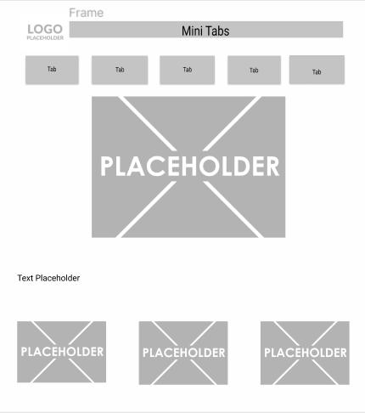

Hit the Trails Page

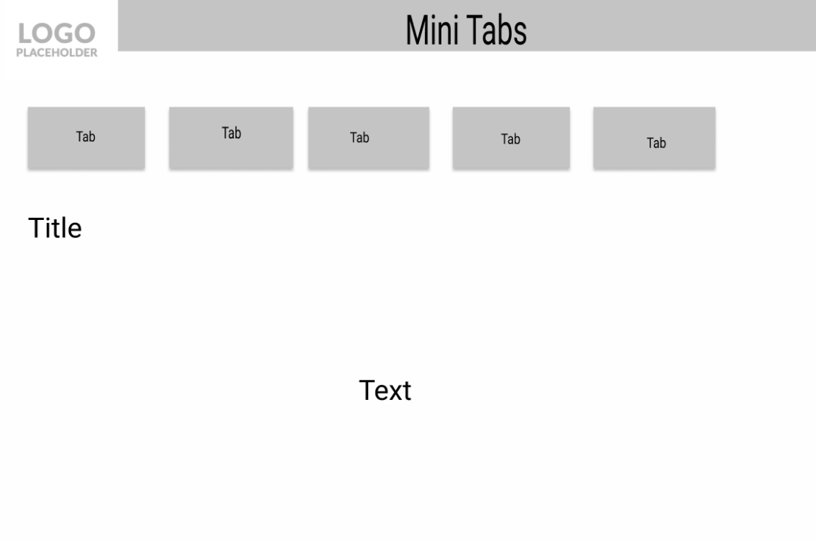

Choose Your Adventure Page

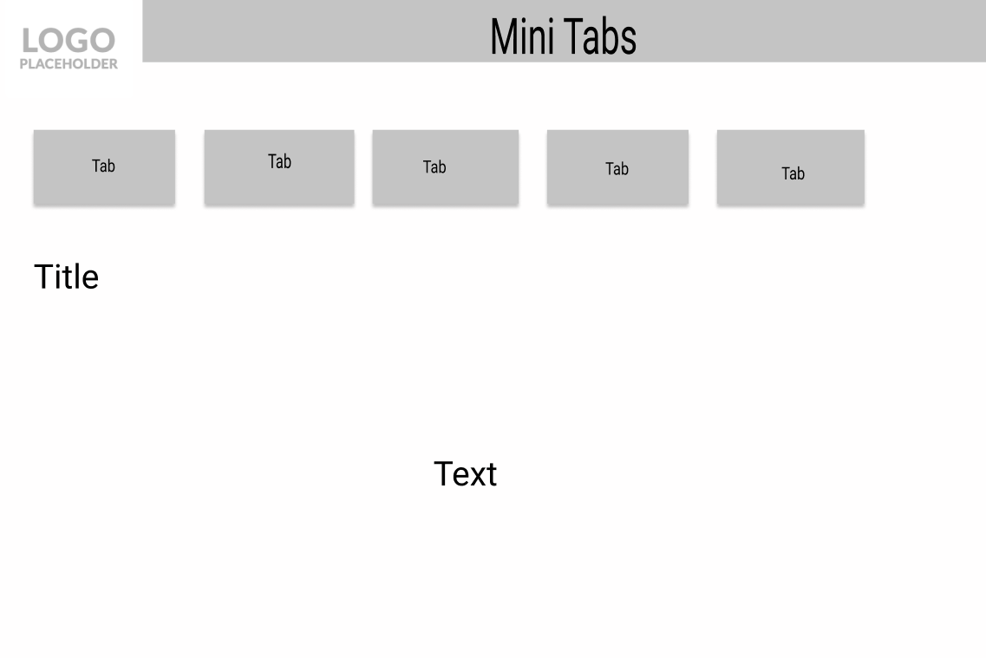

Programs/Events Page



Get Involved



The Forest/Natural Areas Page

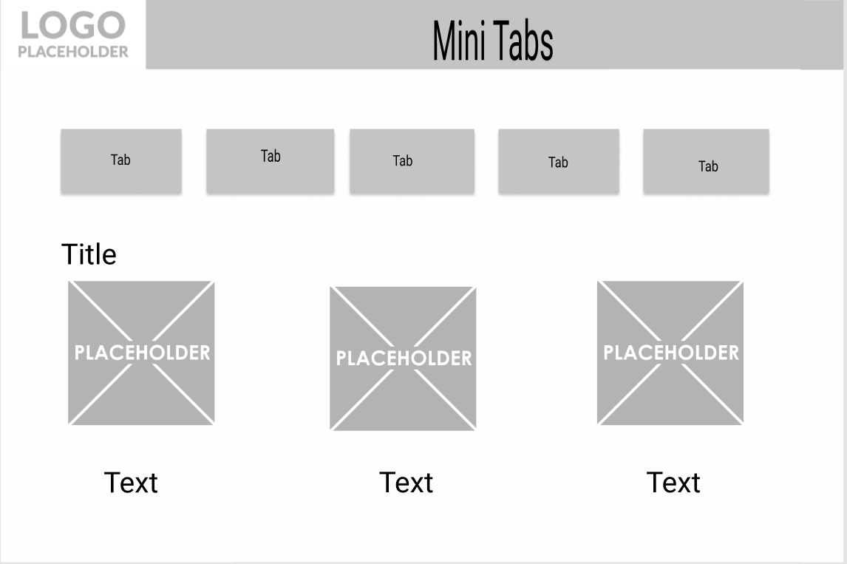

About Us Page (see website features for specs) 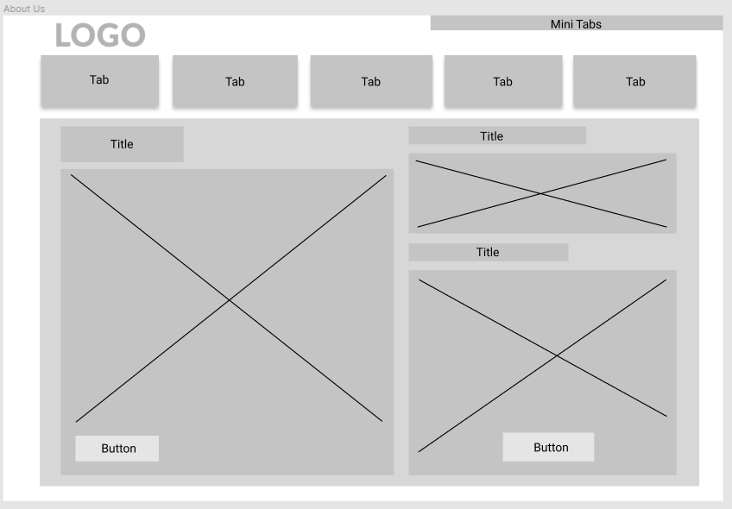

Calendar Page (See website features for specs) 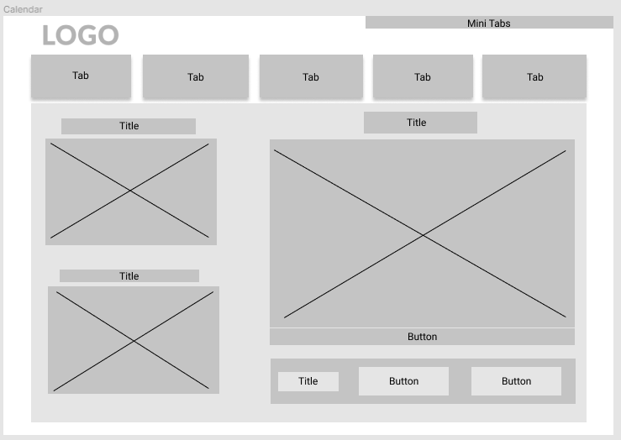

News Page

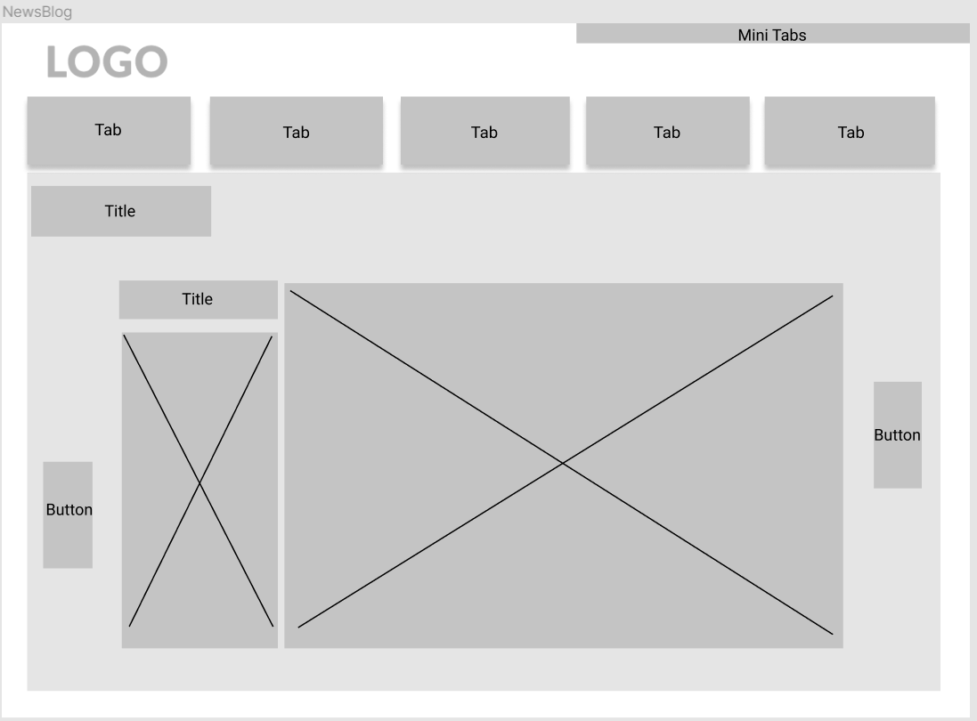

Contacts Page 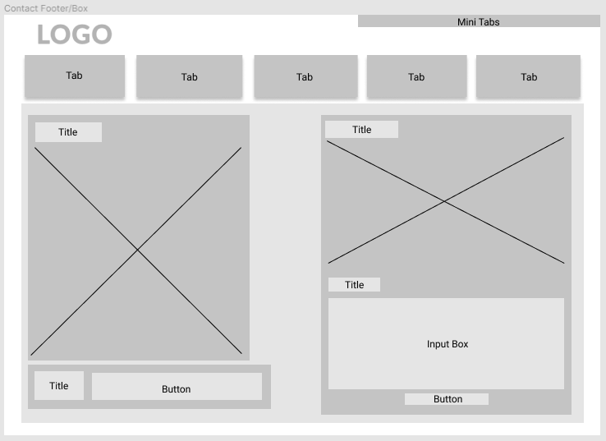

Staff/Board Page 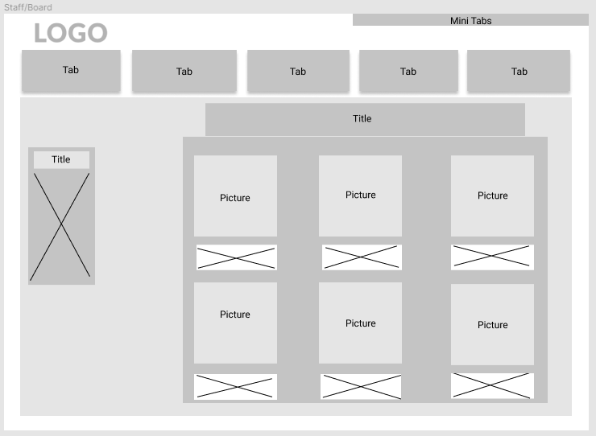

Login Page

Donate Page

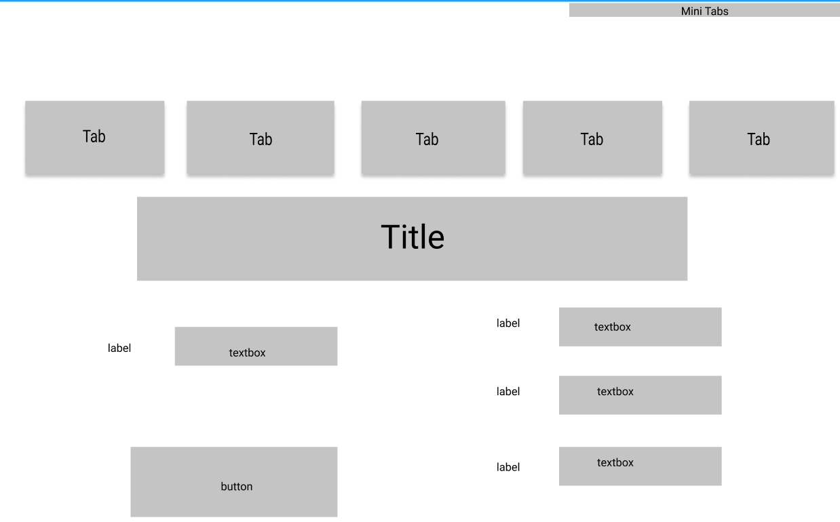

Membership Page

Weather Page

Visitor Navigation Page

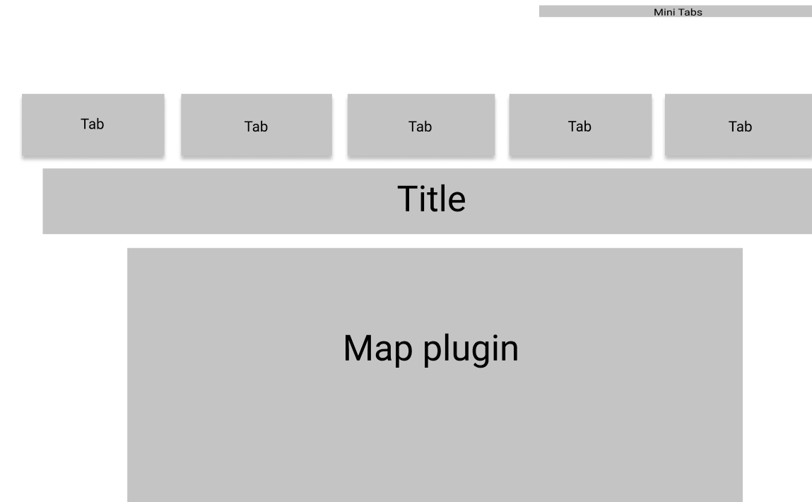

Registration and Payment Page

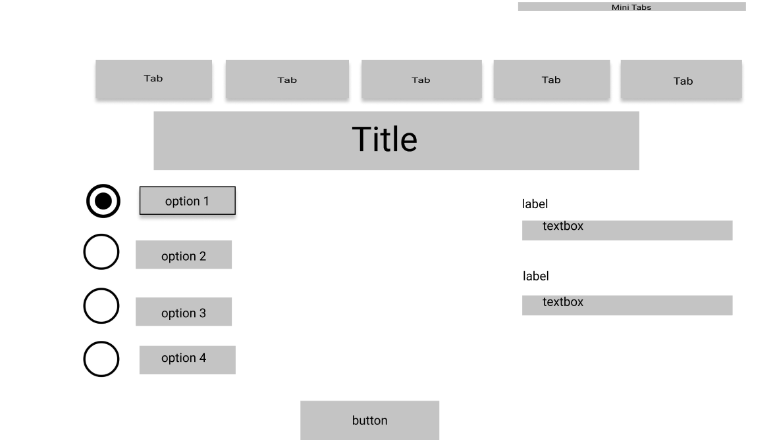

Shop/Merchandise Page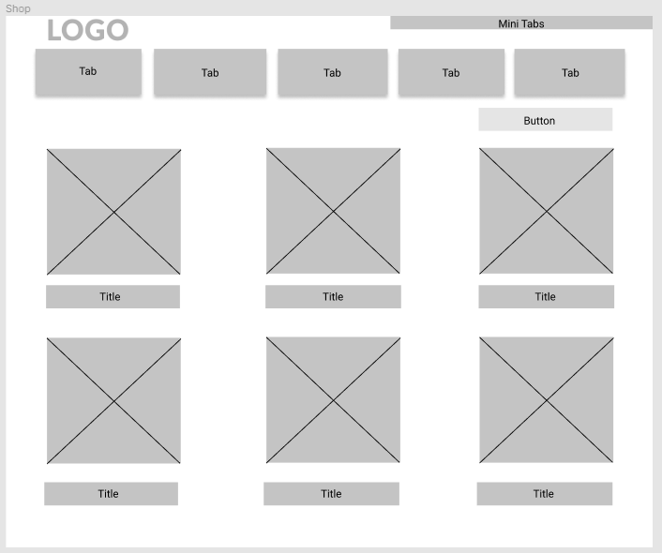

Job Postings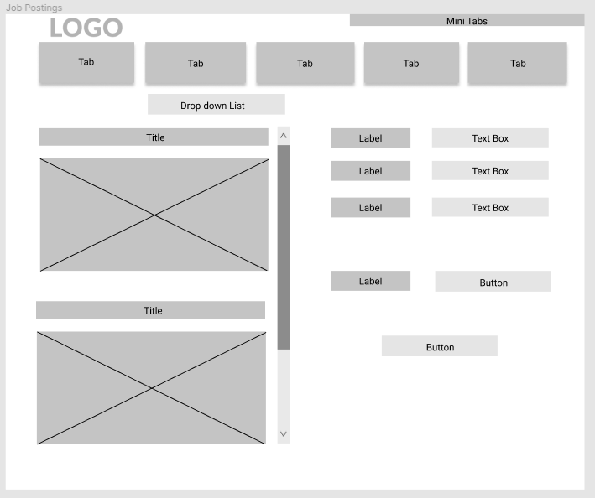

Key initiatives page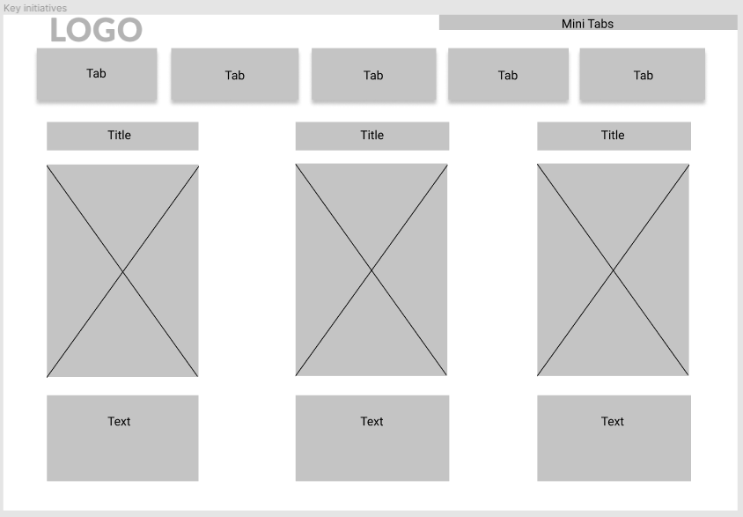

ECHO Programming